Solution for Chapter 6

- (a) The pipeline execution diagram for the given code is shown below.
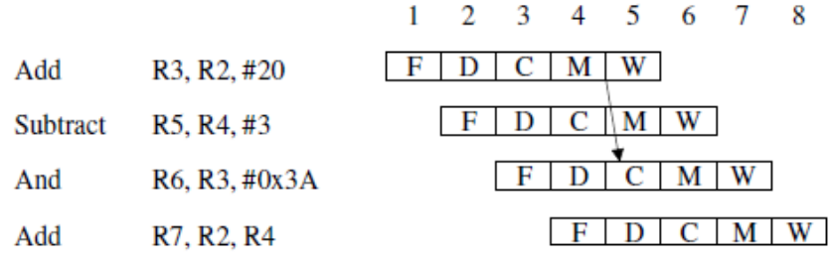
The description of activity in each stage during each cycle is the same as in part (a) of Problem 6.1, except that the previous contents of register R3 are read by the And instruction in cycle 4, but the Compute stage uses the new value of 2020 that has been computed by the first Add instruction. The differences with the solution for part (a) of Problem 6.1 are highlighted in italics in the partial table given below.
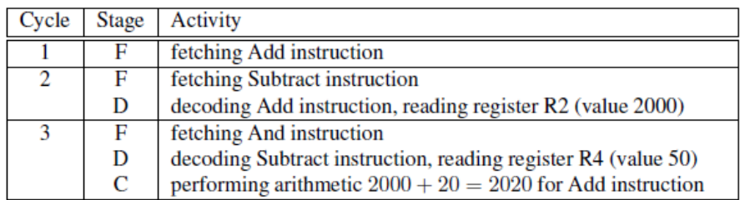
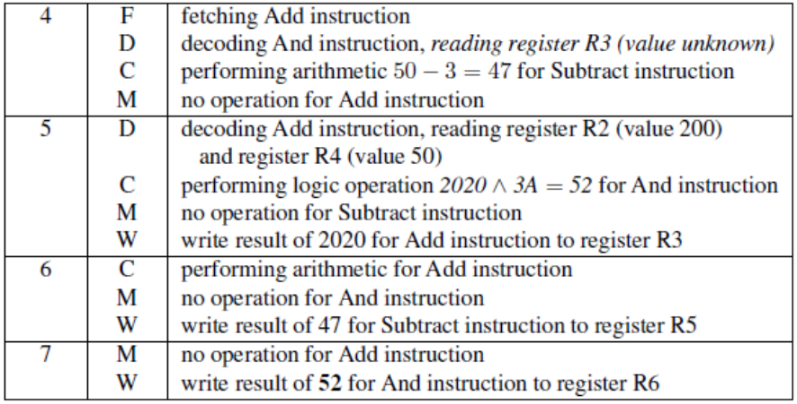
(b) The contents of each register during each cycle are described in the table below. The differences with the equivalent table in part (b) of Problem 6.1 are highlighted in boldface.
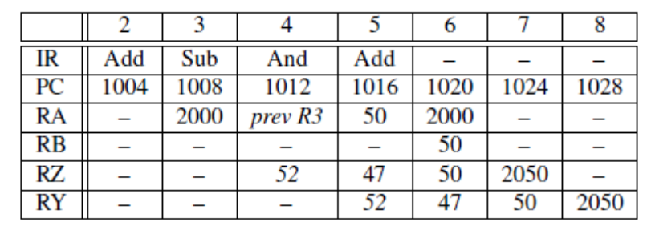

 | 2 | 3 | 4 | 5 | 6 | 7 | 8
IR | Add | Sub | And | Add
PC | 1004 | 1008 | 1012 | 1016 | 1020 | 1024 | 1028
RA |  | 2000 | 50 | Pre R3 | 2000
RB |  |  |  |  | 50
RZ |  |  | 2020 | 47 | 32 | 2050
RY |  |  |  | 2020 | 47 | 32 | 2050

The contents of RZ in cycle 4 and RY in cycle 5 are determined as follows:
2020 ^ 3A16 = 7E416 ^ 3A16 = 2016 = 52（应改为32）

- The instruction sequence consists of four memory-access instructions and four arithmetic instructions.
Using the original order of instructions, there are two cases to consider for dispatching pairs of instructions in the superscalar processor.

Case 1: The processor imposes the restriction that two instructions being dispatched in the same cycle must be of distinct types to reduce the complexity at each execution unit. In the pipeline execution diagram below, memory-access instructions are denoted as Mi and arithmetic instructions are denoted as Aj .
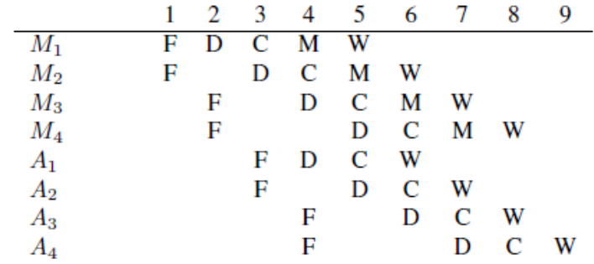

Case 2: The processor allows two instructions of the same type to be dispatched in the same cycle with more complex buffering at each execution unit. Simultaneously dispatched instructions of the same type are still handled with pipelining in their execution unit, so the completion of all activity requires the same number of cycles as the first case above.
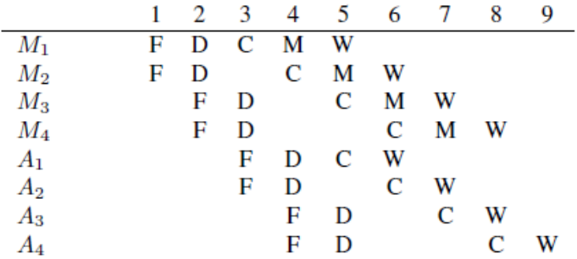
Now, rather than preserving the original order of instructions, it is possible to interleave the memory-access and arithmetic instructions in a revised instruction sequence. If such an interleaved sequence is used, the pipeline execution diagram below shows that one less cycle is required to complete all activity.
